Chromatography of anthocyanin pigments

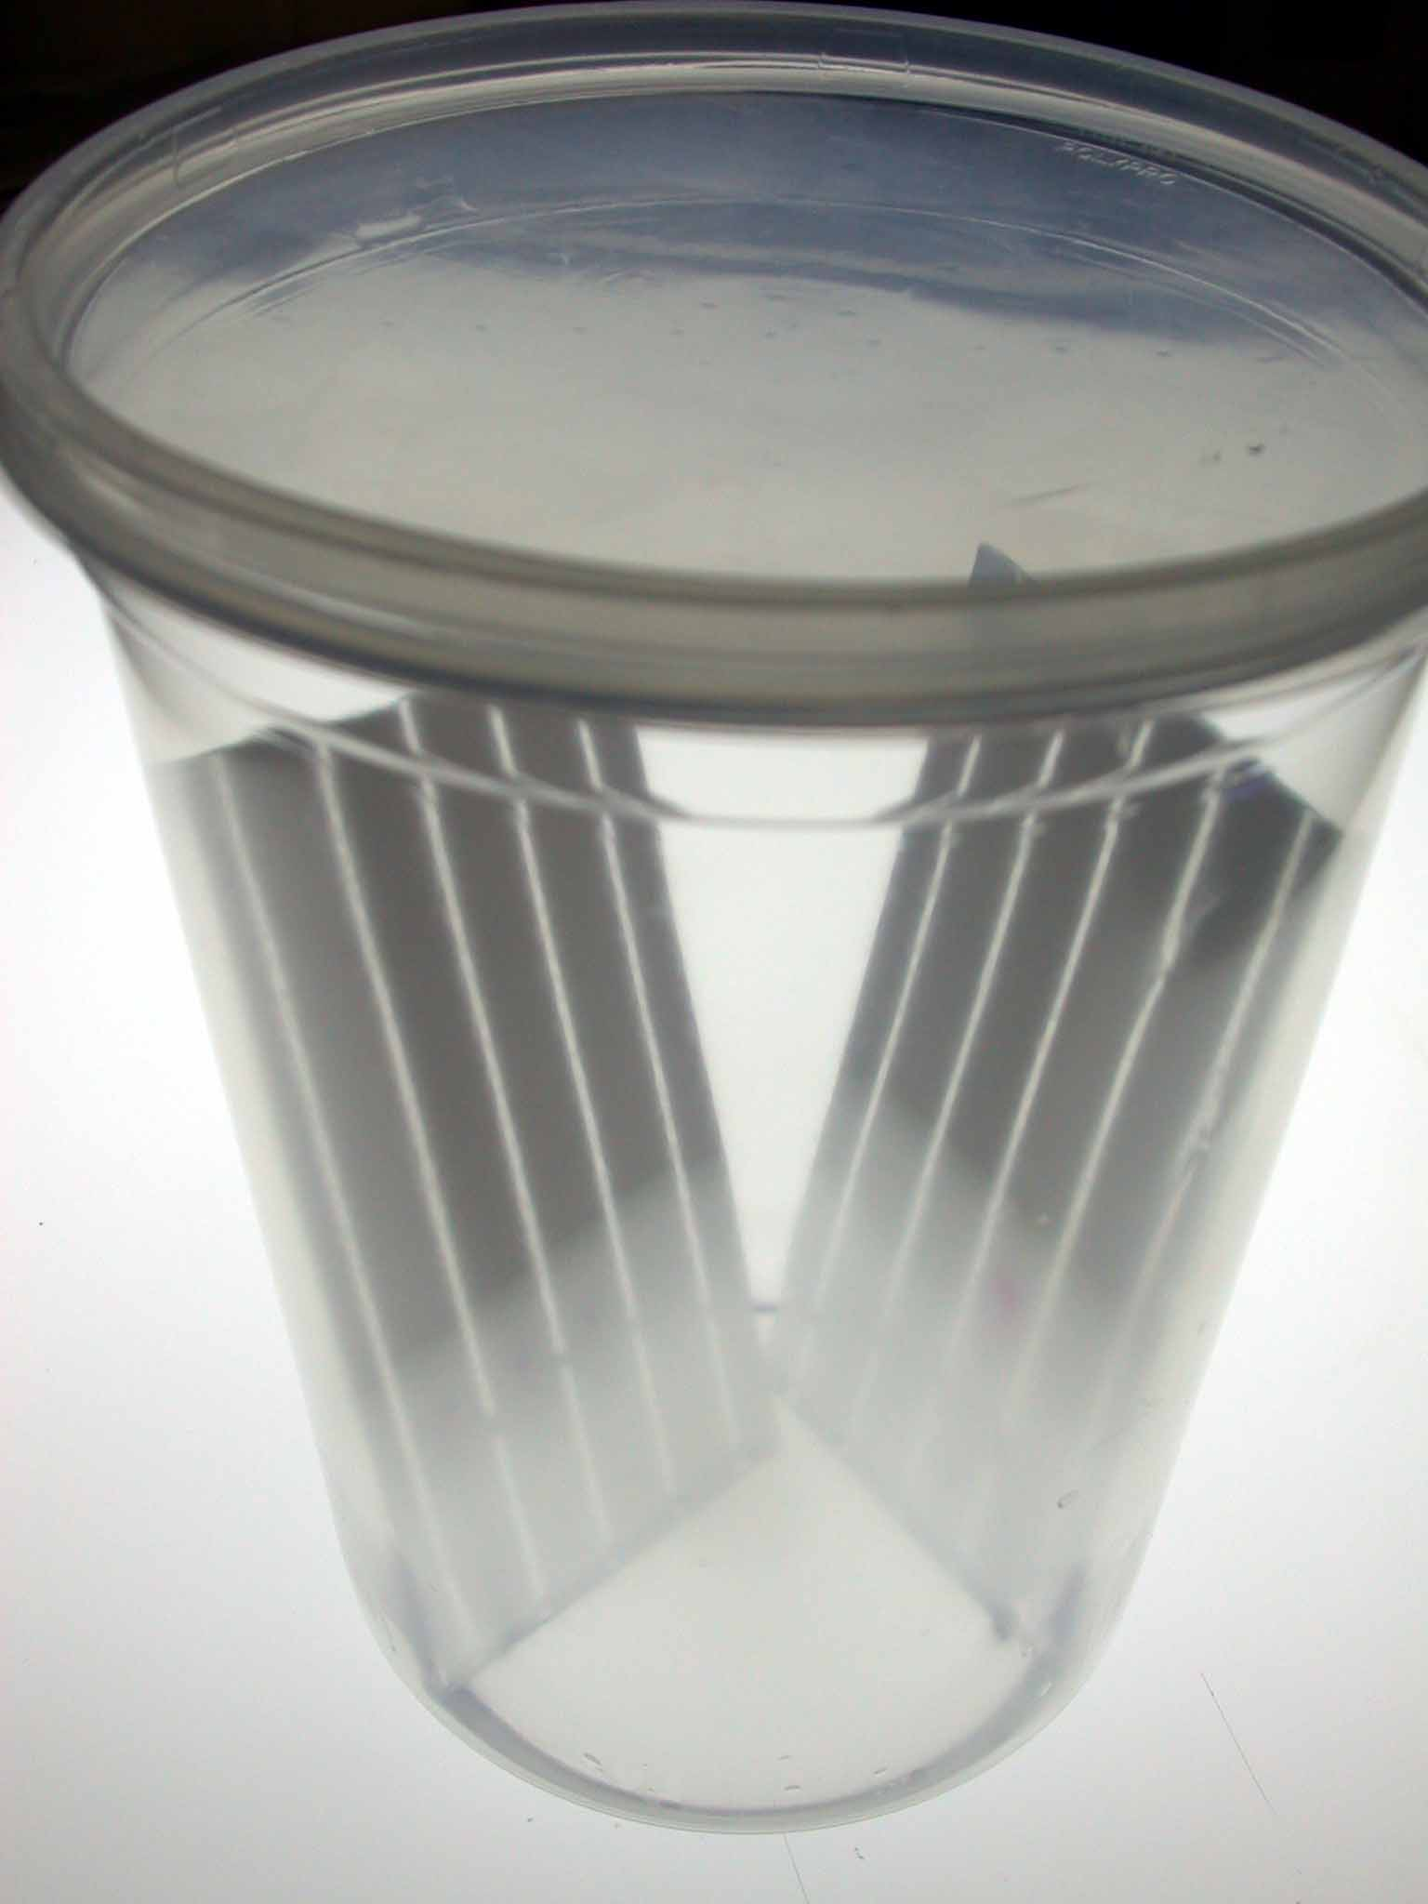

AIMS Workshop
Prepared by May Berenbaum and Art Zangerl, Dept. of Entomology, University of Illinois at Urbana-Champaign

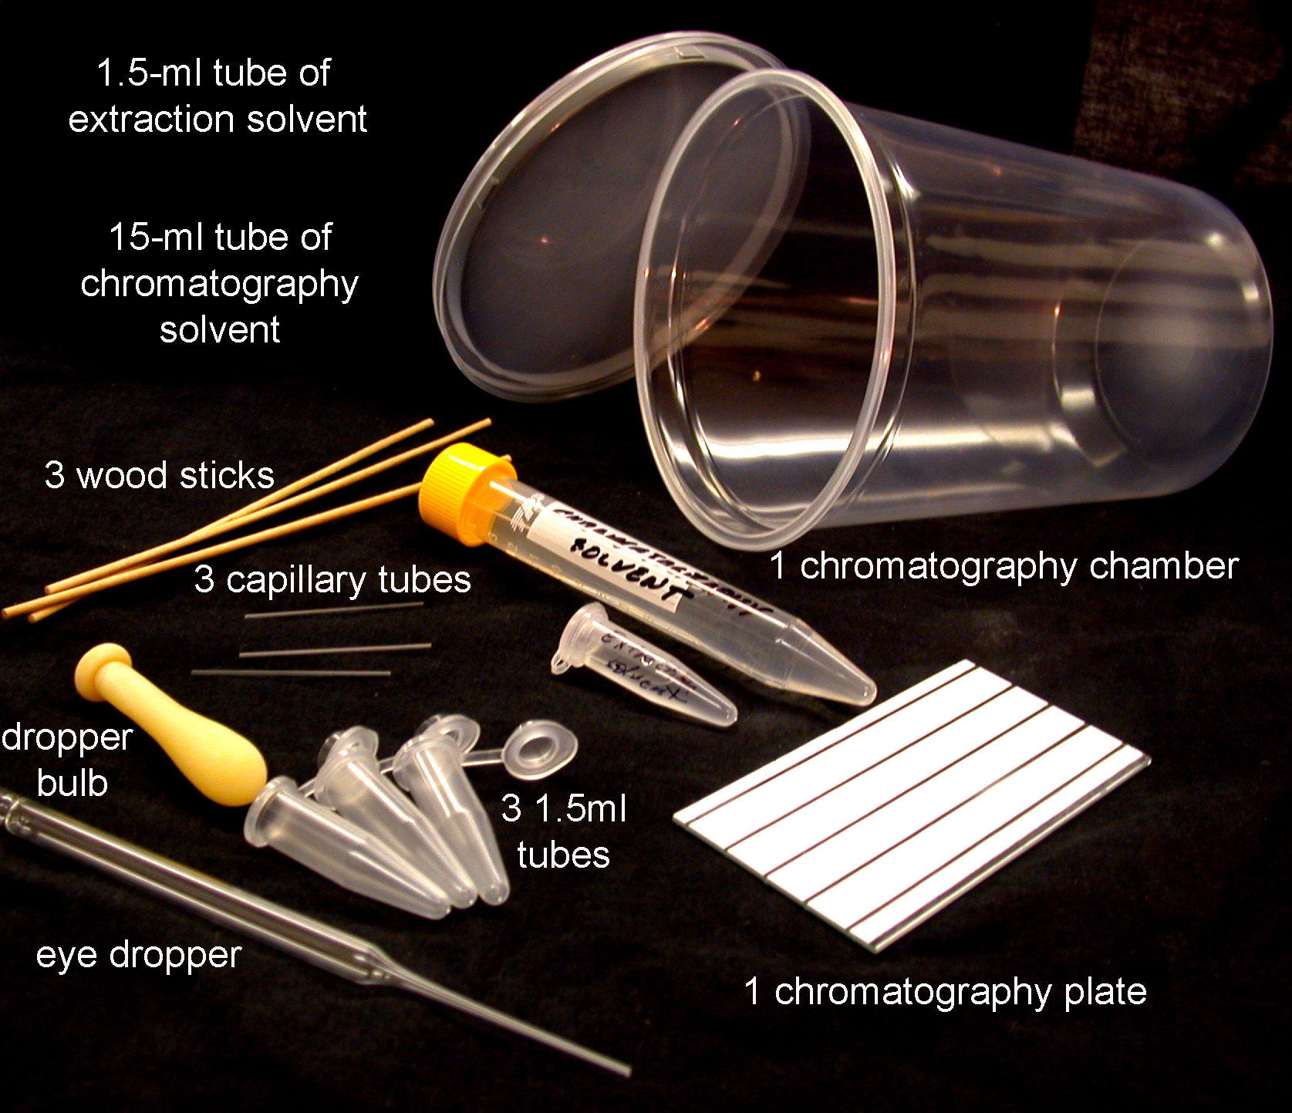

Chromatography and extraction solvent (one tube per group):

2 parts acetic acid
2 parts water
6 parts propanol

or

9 parts rubbing alcohol
1 part vinegar

Procedure

1___Select a purplish seedling (P), a non-purplish seedling (NP) and one of intermediate purplishness (I). Select seedlings that are about the same size. Label the 1.5 ml extraction tubes as “P”, “I”, and “NP”, respectively.

2___Put each seedling into the appropriate 1.5ml extraction tube (purple plant in P, intermediate in I and nonpurple in NP).

3___Add three drops of extraction solvent to each tube.

4___Using a wood applicator, thoroughly macerate the seedling (about 1 minute per tube) by crushing with a twisting motion the tissue into the bottom of the tube. Then cap the tube to prevent evaporation of the solvent.

5___Take the TLC plate, place it inside the chromatography chamber so that it rests with the coating on the upper slope. Pour all of the contents of the chromatography solvent vial over the plate, so that all of it is wetted. Remove the plate and cover the chromatography chamber to keep the solvent from evaporating. The white lines on the plate should look gray, possibly with mottling. Dry the plate with a hair drier or just blow on it until it is white again. What you have just done is a quick and dirty pre-run of the plate, which conditions it for the real run. Lightly, draw a line (origin) with a pencil across the width (narrowest dimension) of the plate 1 cm from the edge. Then, if the plate does not have distinct lanes on it, draw three short vertical lines spaced evenly along the origin. Be careful not to press too hard on the plate, if you do, you might scratch off the coating.


You should then label the three positions on the plate with “P”, “I”, and “NP”.

7___Using the spotter (capillary tube), draw up liquid from one of your extraction tubes. Deposit the sample on the origin line at the appropriate position. Do this a bit at a time, allowing sample to dry between applications (a hair drier speeds this process dramatically—the spot should be no more than a millimeter in diameter). Repeat with the second extract and finally the third one. You should now have each position on the plate spotted. Be sure to label the plate with a pencil at the opposite end from the origin with your group name.

8___Place the TLC plate with the origin down into the chromatography chamber. The solvent should not be higher than the origin. Allow the solvent to travel up the plate (develop) for about 15 minutes.

9___Remove the plate and allow it to air dry.

The plates may be photographed for use in quantification of pigment by Scion Image for Windows software. If you do photograph the plate, you should have even light across the plate and shoot directly over it (not at an angle). Depending on the file format of the pictures that your camera produces, you may have to convert the files for use in Scion Image (available free from http://www.scioncorp.com/frames/fr_download_now.htm). Scion will open TIF and BMP formats. Using Paint software, open your picture and using the rectangular selection tool draw a box so as to select only the area shown below (you may not have plates with distinct lanes like these) or make sure you get all of the purple spots. Then cut this selection and open a new file in which to paste it. Save the new file in BMP or TIF format.

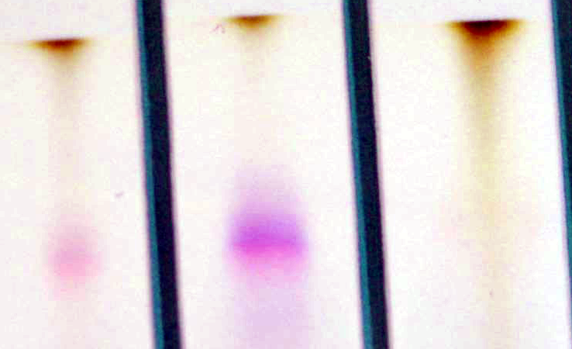

Scion Image analysis

Open software and then open, from the “File” pull-down, the filename of the picture of your TLC Plate in BMP or TIF format. Don’t be surprised that picture you see is in black and white, rather than color. Picture files contain different color layers. It is intensity of a pixel within each color layer that determines the color of the pixel that you ordinarily see. What you are seeing here is intensity of color layer. To select the color layer (there are only 3) which gives the best range of intensity do the following:

Under “Stacks” pull-down, select “next slice” to get green bitmap, which gives a nice continuous-tone image (if you like, you move back and forth between slices to confirm that the green one is best).

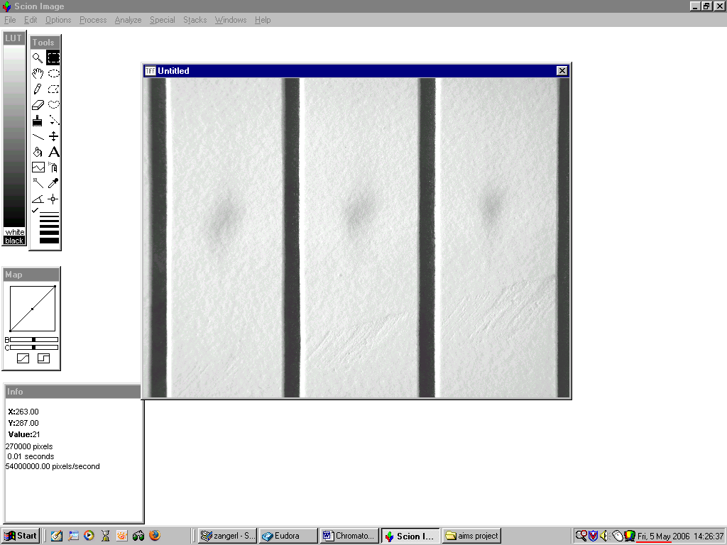

Using the box selection tool, drag a box around the spot you wish to measure (remember that you want to measure the spots that were purple in the original picture):

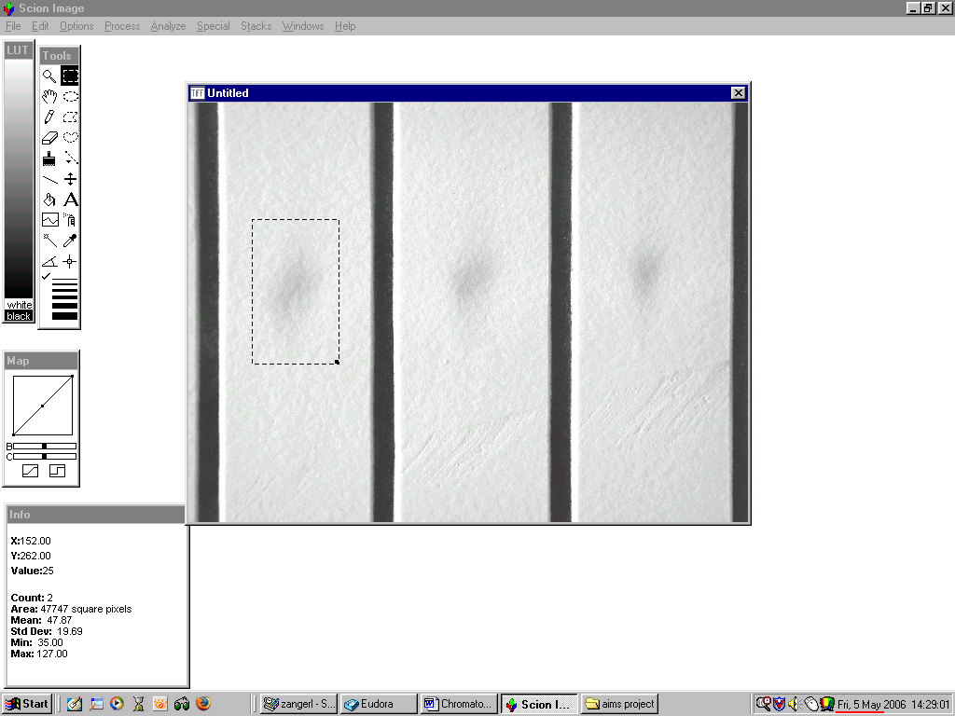

Under “Options” pull-down. select “density slice”

Using the slide tool from the tool window, move the red edges of the LUT window until all of the spot is red—you are effectively selecting the pixels for analysis (indicated by the red) that you think are different in intensity from the “background”(the white area around the spot):
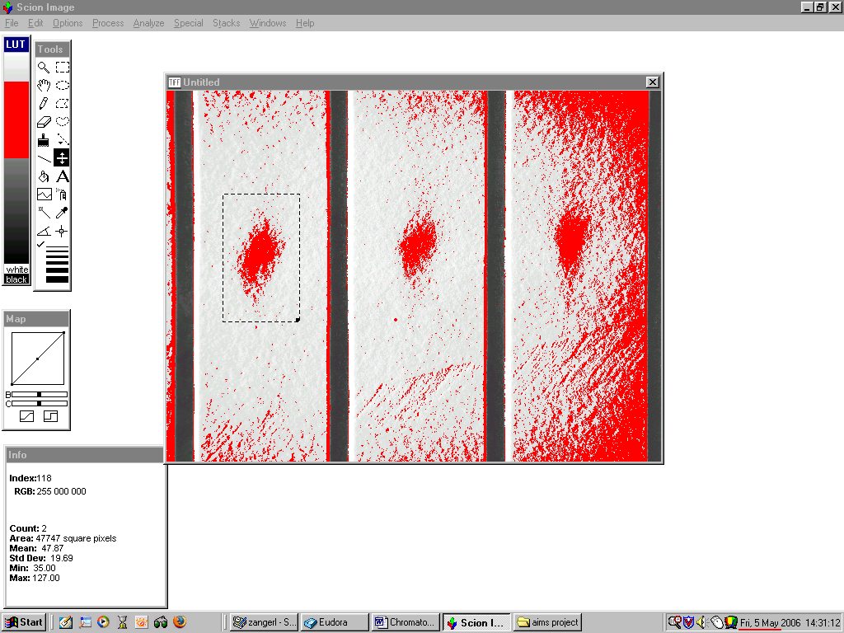

Next, under “Analyze” pull-down, select “Measure”.
Now, move the box to the next spot by selecting the box tool and dragging the box over the next spot and do another “Measure”

To see the results, under “Analyze”, select “show results”:

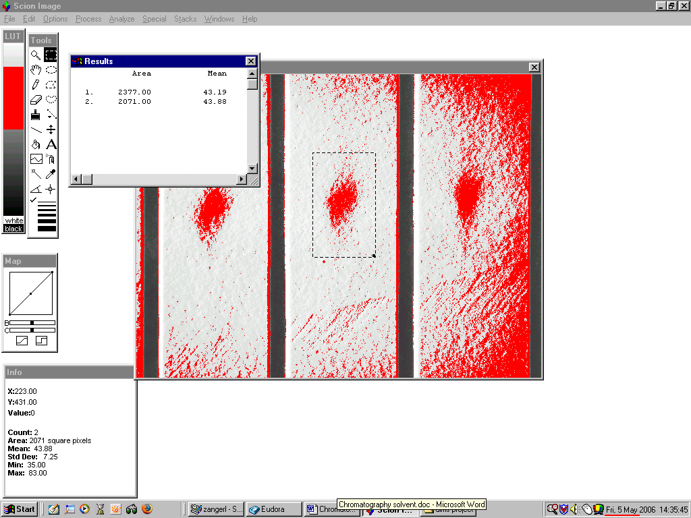

The amount of pigment in a spot will be proportional to the product of the mean (mean intensity) and the area of the spot, so for the first spot we measured, it will be 2377 x 43.19 or 10266.

Share spot intensity data with other groups and do statistical analysis (e.g., t-test comparing P spot with I spot and NP spot with I spot). Are there significant differences?

